New York University

Database Systems - CSCI-GA.2433-001
Ronojoy Mitra

Database Systems Project Part III – Physical Database Design and Machine Learning Model Creation

I - Introduction
- This report covers part 3 of the Database Systems project. This part continues to build on parts I and II of the project, working with the insurance company with the business goal of forecasting chronic disease risk to inform insurance rates by using factors such as social vulnerability, health behaviour and environmental condition.

Part III takes the logical schema that was developed earlier and performs and deploys a physical database design utilizing techniques such as indexing, partitioning, clustering and selective materialization. Part III also documents use cases and a process for the quote to policy workflow and creates/trains machine learning models to extract insights from the collected data. Additionally Part III also extends the big data platform with cloud analytics and refines the end to end architecture.

II - Physical Database Design
- The physical database design is designed after the implementation of the logical schema in PostgreSQL from part II. The database system is deployed locally in the database titled ‘insurancecomp2_eda’ under the eda schema. The techniques applied during the physical design are as follows
  - Indexing:
    - Since PostgreSQL automatically created an index to enforce a primary key but it didn’t index foreign key columns thus every foreign key in the schema was unindexed by default. Explicit indexes were created on all foreign key columns across the geography. product, account, member, contract, provider, clinical, and data lake layers.

In addition to referential integrity, four query pattern indexes were added.
- A composite index on geo_health_indicator(county_id, indicator_code, measure_year) was added supporting the central data lake read pattern. The county_id leads since it is the most selective and always supplied, thus the index also covers county only lookups. A second single column index on county_id was not created since it would duplicate coverage that is already provided by the composite index.
- Partial indexes were created on contract and account that are restricted to in force policies and active accounts respectively. Since Quote and renewal workflows only look at current records a partial index stays small and cached.
- A GIN index was created on unstructured_asset.parsed_data since GIN indexes can document the content and the column holds semi-structured JSONB whose keys are not known in advance.
- Indexes were added on the tract and county keys to support the tract level joins used by the ML feature extraction.
As a result of these the lookup of a single county’s diabetes indicator produced a sequential scan of geo_health_indicator while now the same query produces an index scan with substantially fewer buffer reads

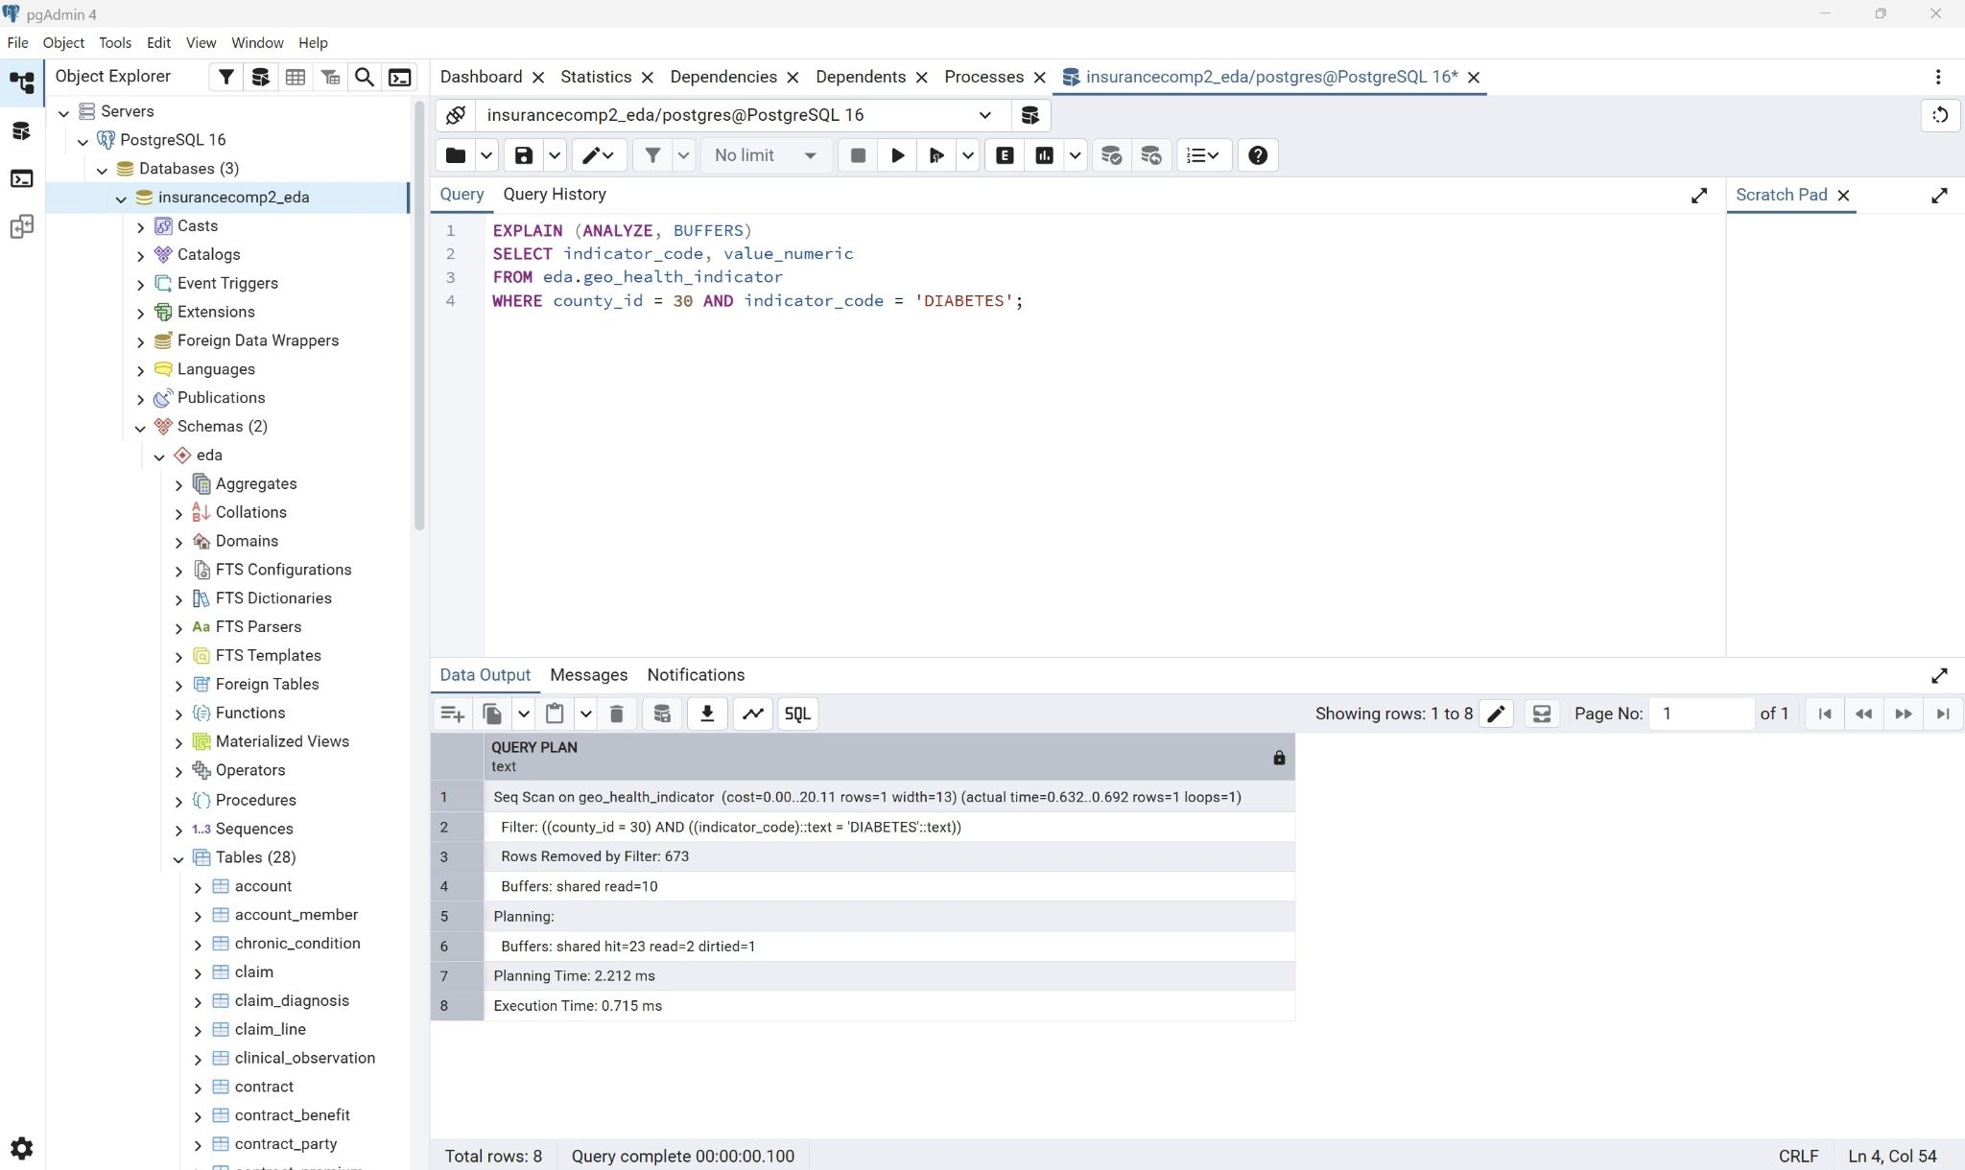
Figure: pgAdmin - EXPLAIN ANALYZE showing Seq Scan on geo_health_indicator before index creation
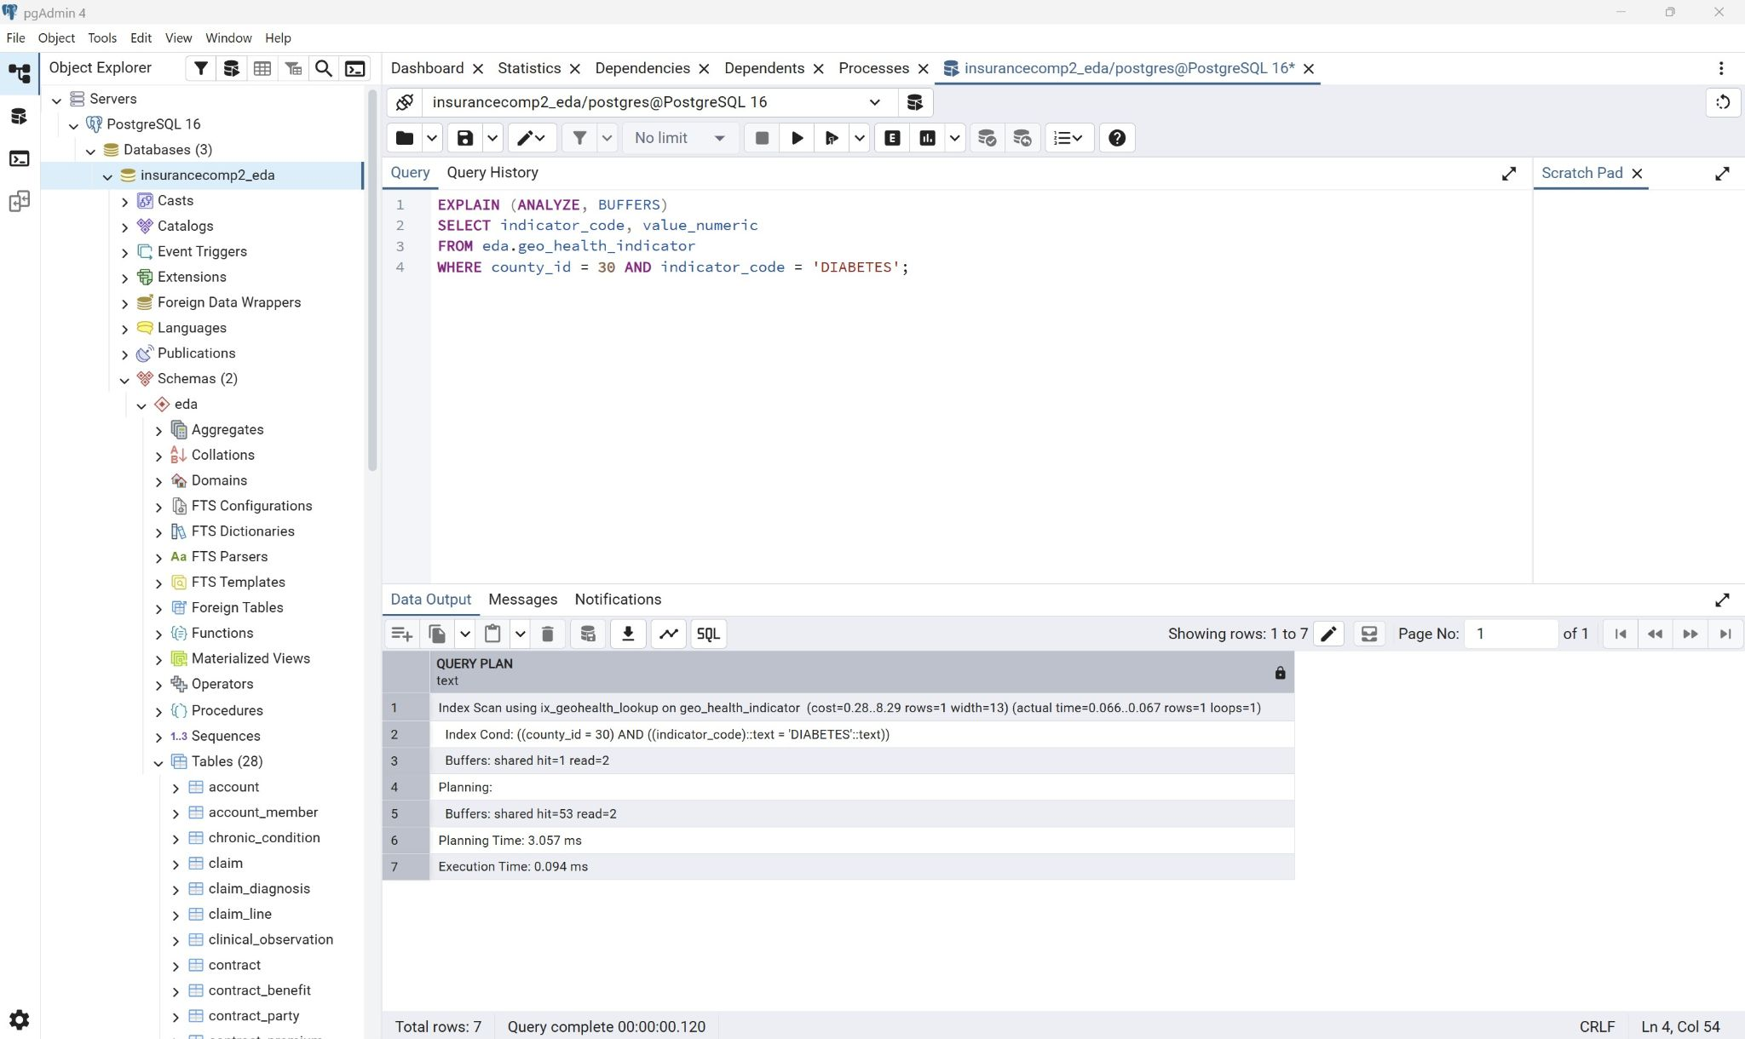
Figure: pgAdmin - EXPLAIN ANALYZE showing Index Scan using ix_geohealth_lookup after index creation
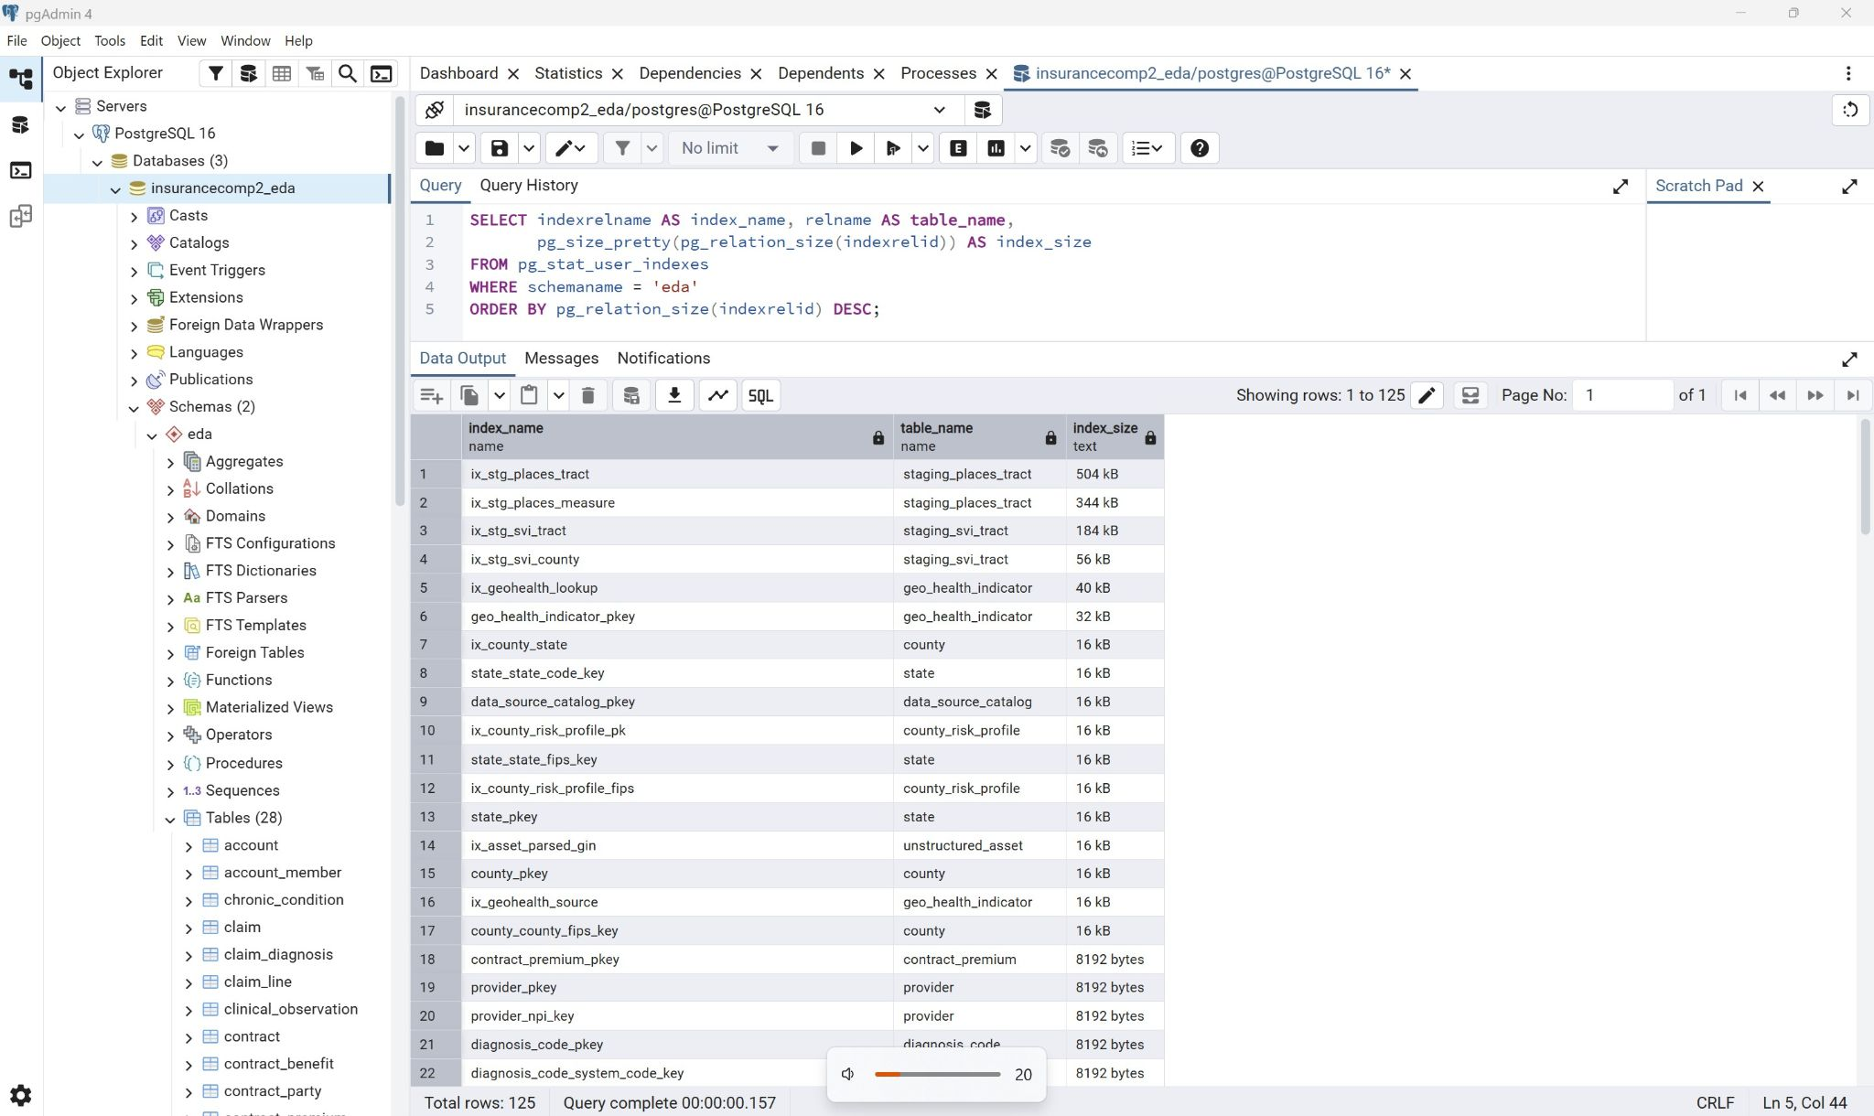
Figure: pgAdmin - full index inventory from pg_stat_user_indexes with sizes

- Partitioning:
  - The claim, claim_line and claim_diagnosis were rebuilt as range partitioned tables partitioned on service_year since they would be three tables that would grow continuously. The partitions were made with one per year for 2022 to 2026 and a default partition.
This allowed a single year query scan to scan one partition instead of the whole history, retention is also cheaper and each partition maintains its own indexes.
The claim’s key became (claim_id, service_year) since a partitioned table’s primary key has to include the partition key and thus foreign keys referencing it became composite.
The indexes were declared on the partitioned parents instead of per partition thus PostgreSQL created and maintains a matching index on every existing partition automatically.

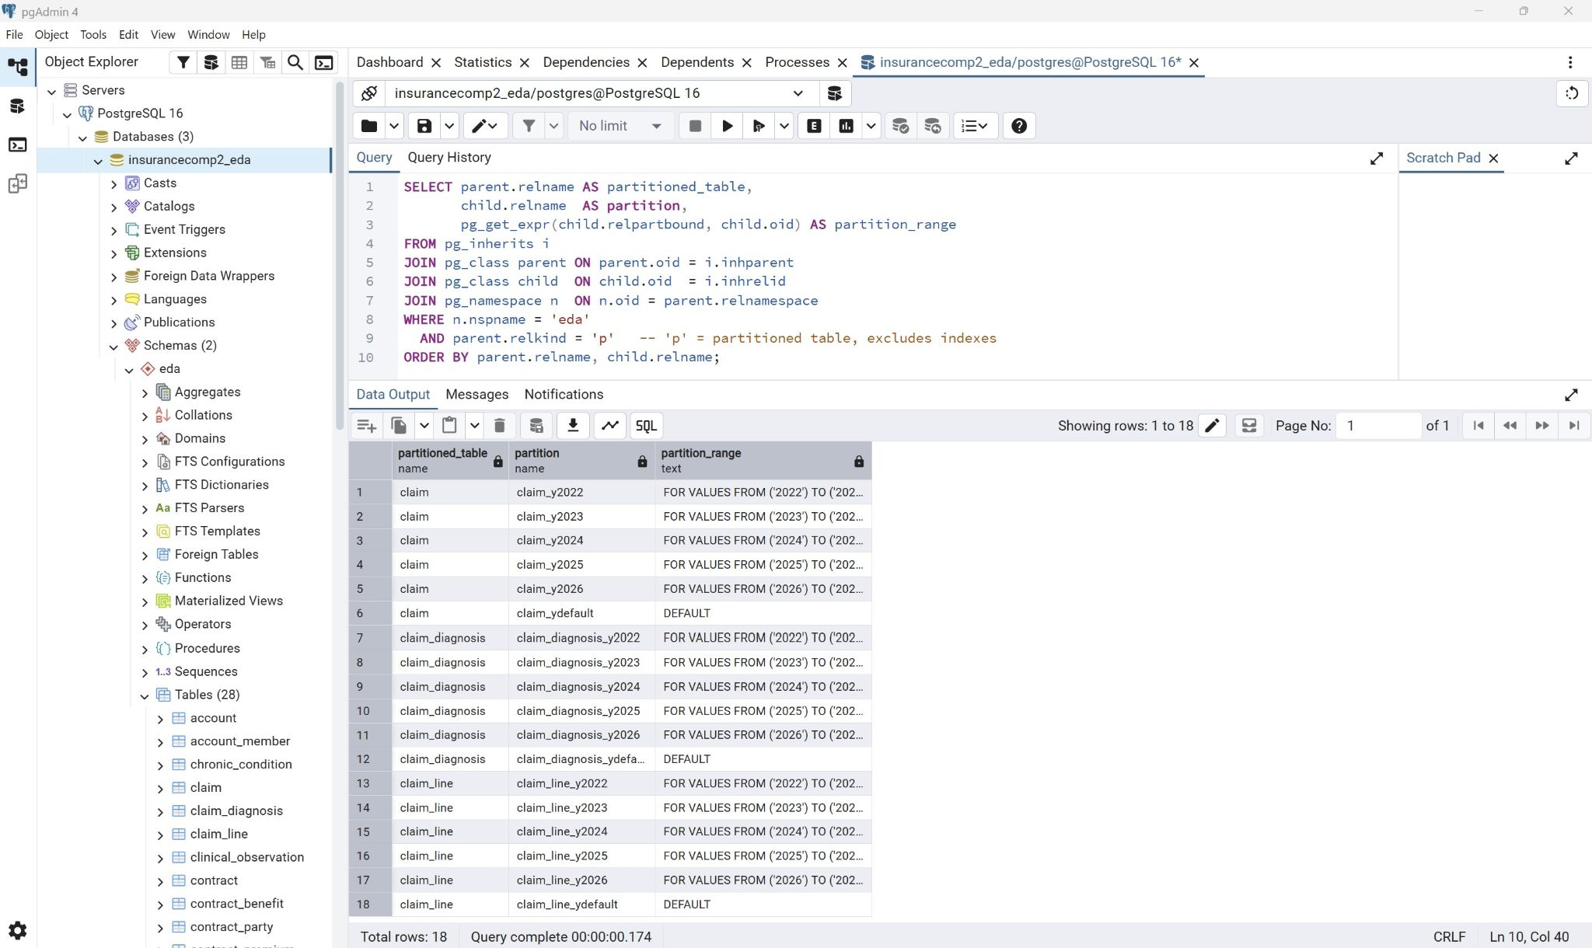
Figure: pgAdmin - partition structure query showing 18 partitions across three claim tables

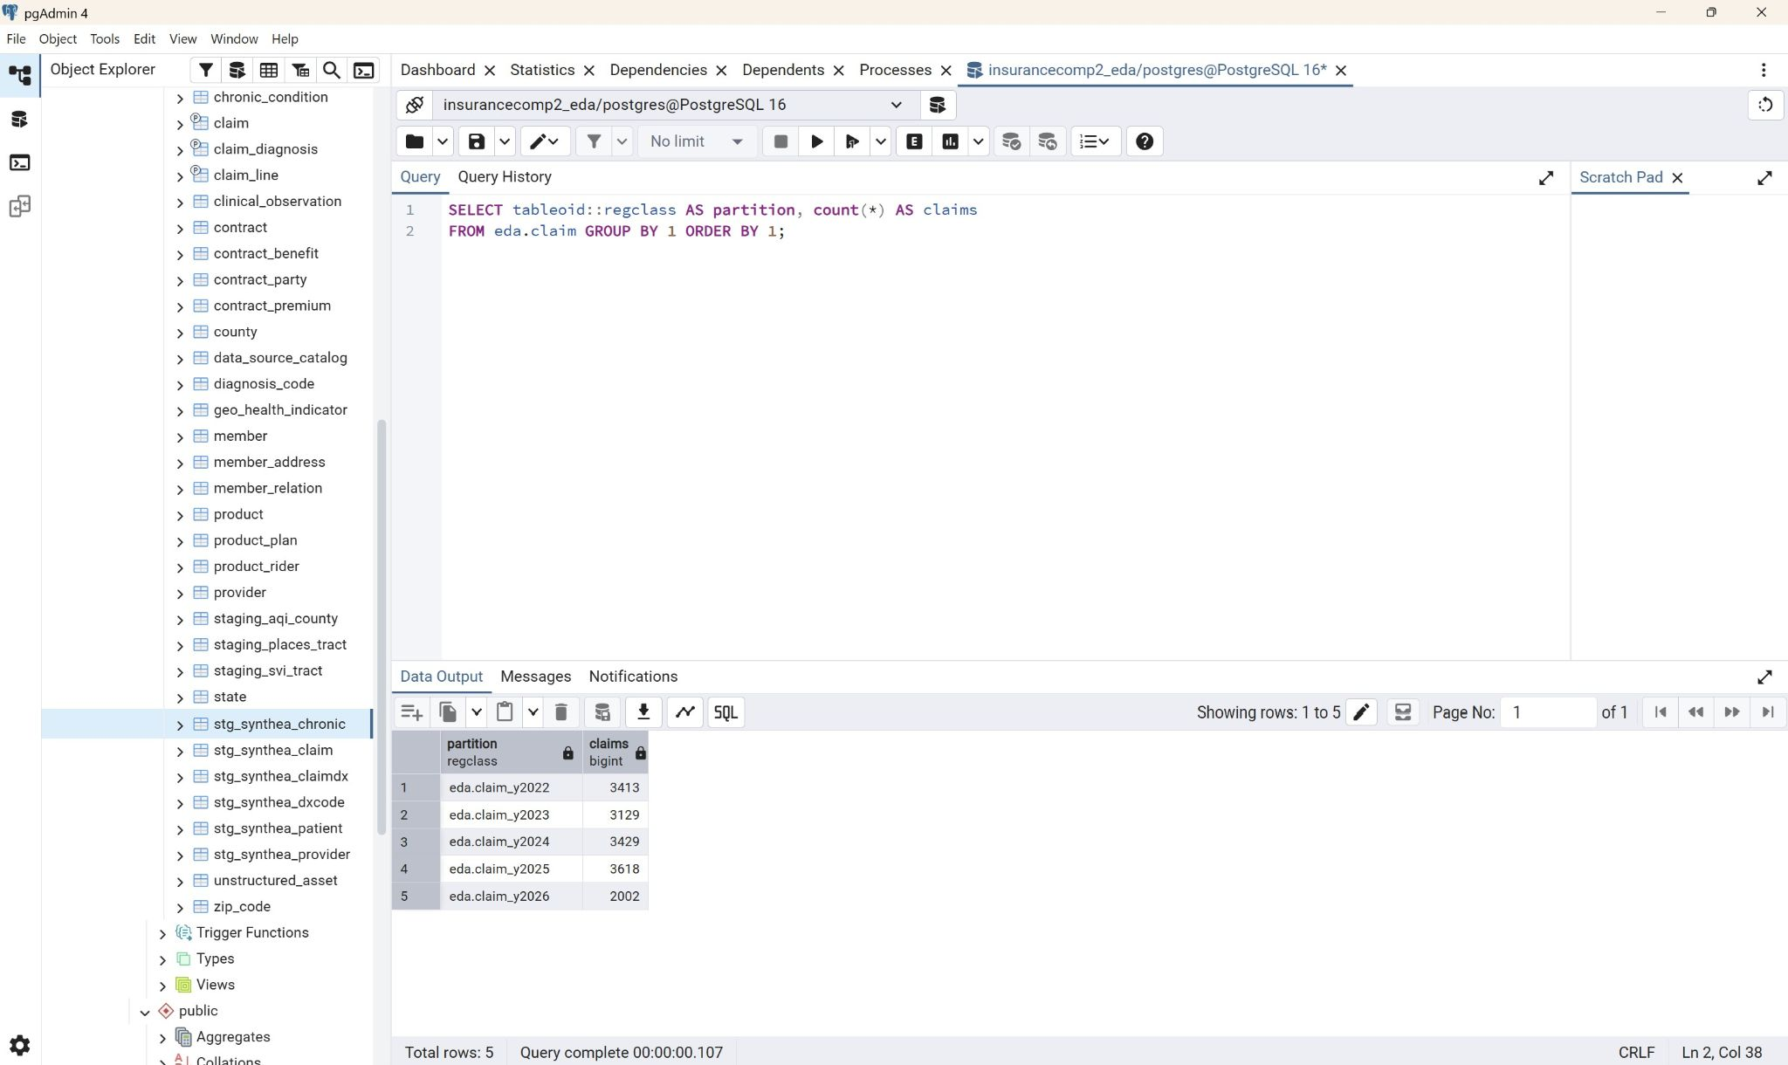
Figure: pgAdmin - claims per partition after load, showing rows in the correct year partitions

Thus a query aggregating 2025 claims only scans the claim_y2025 partition and the other partitions are eliminated at planning time.

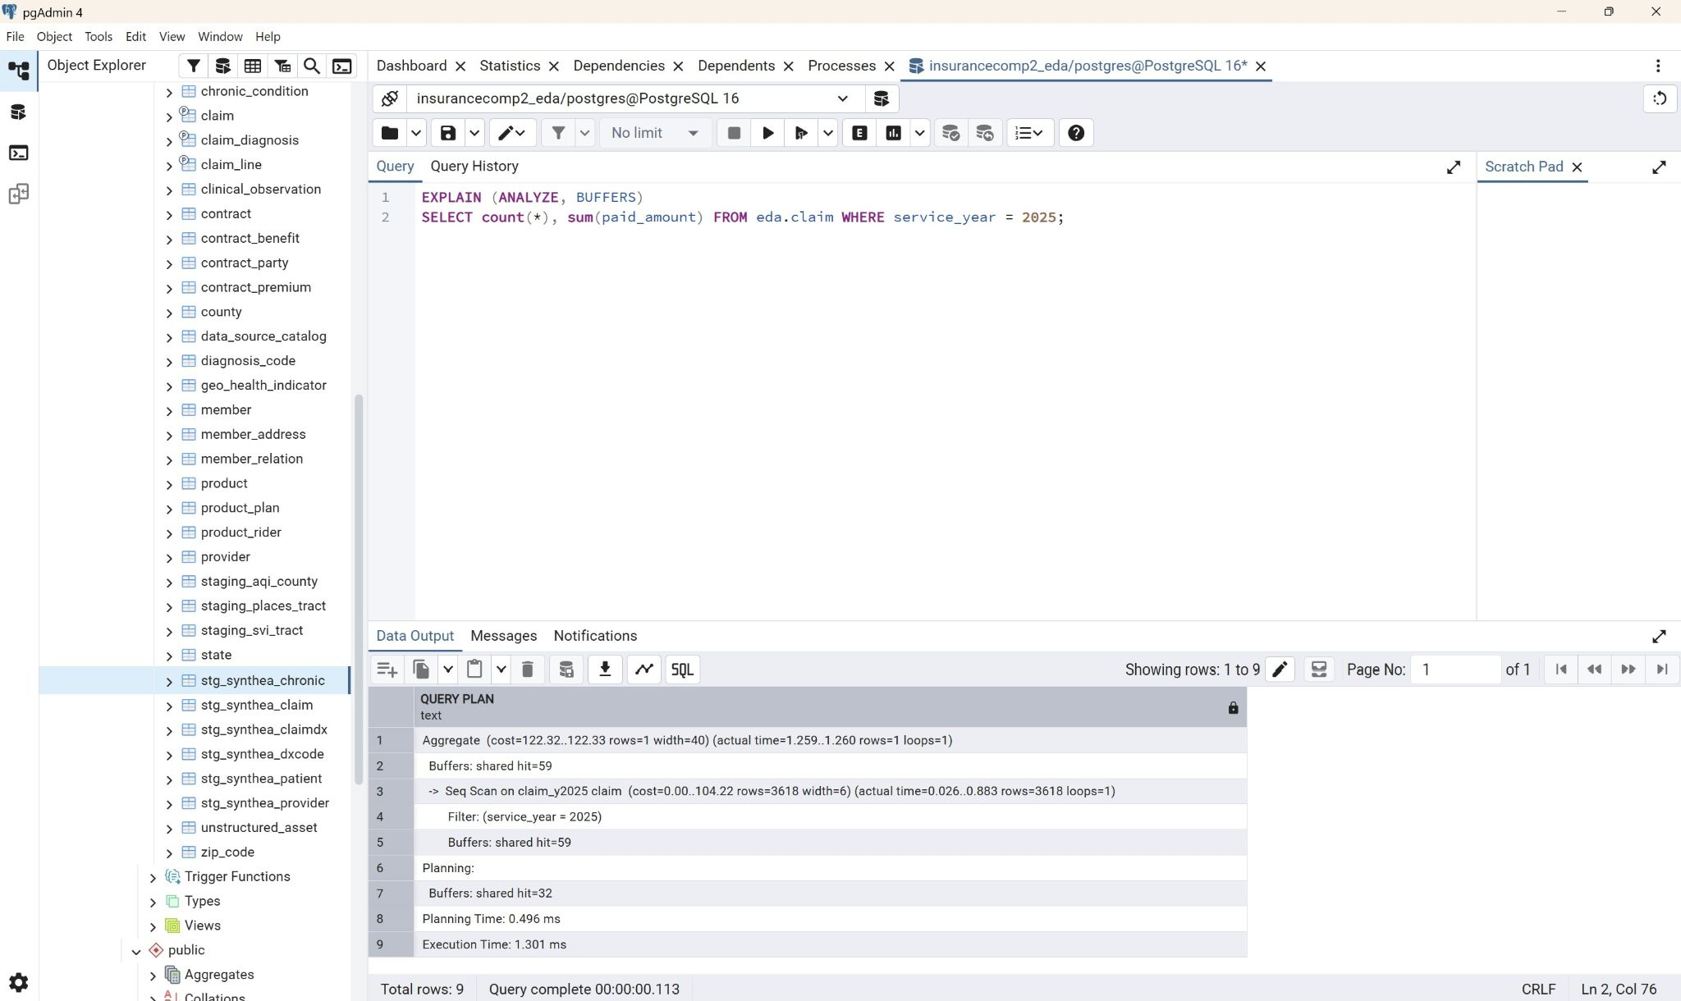
Figure: pgAdmin - EXPLAIN ANALYZE for service_year = 2025 showing only claim_y2025 scanned
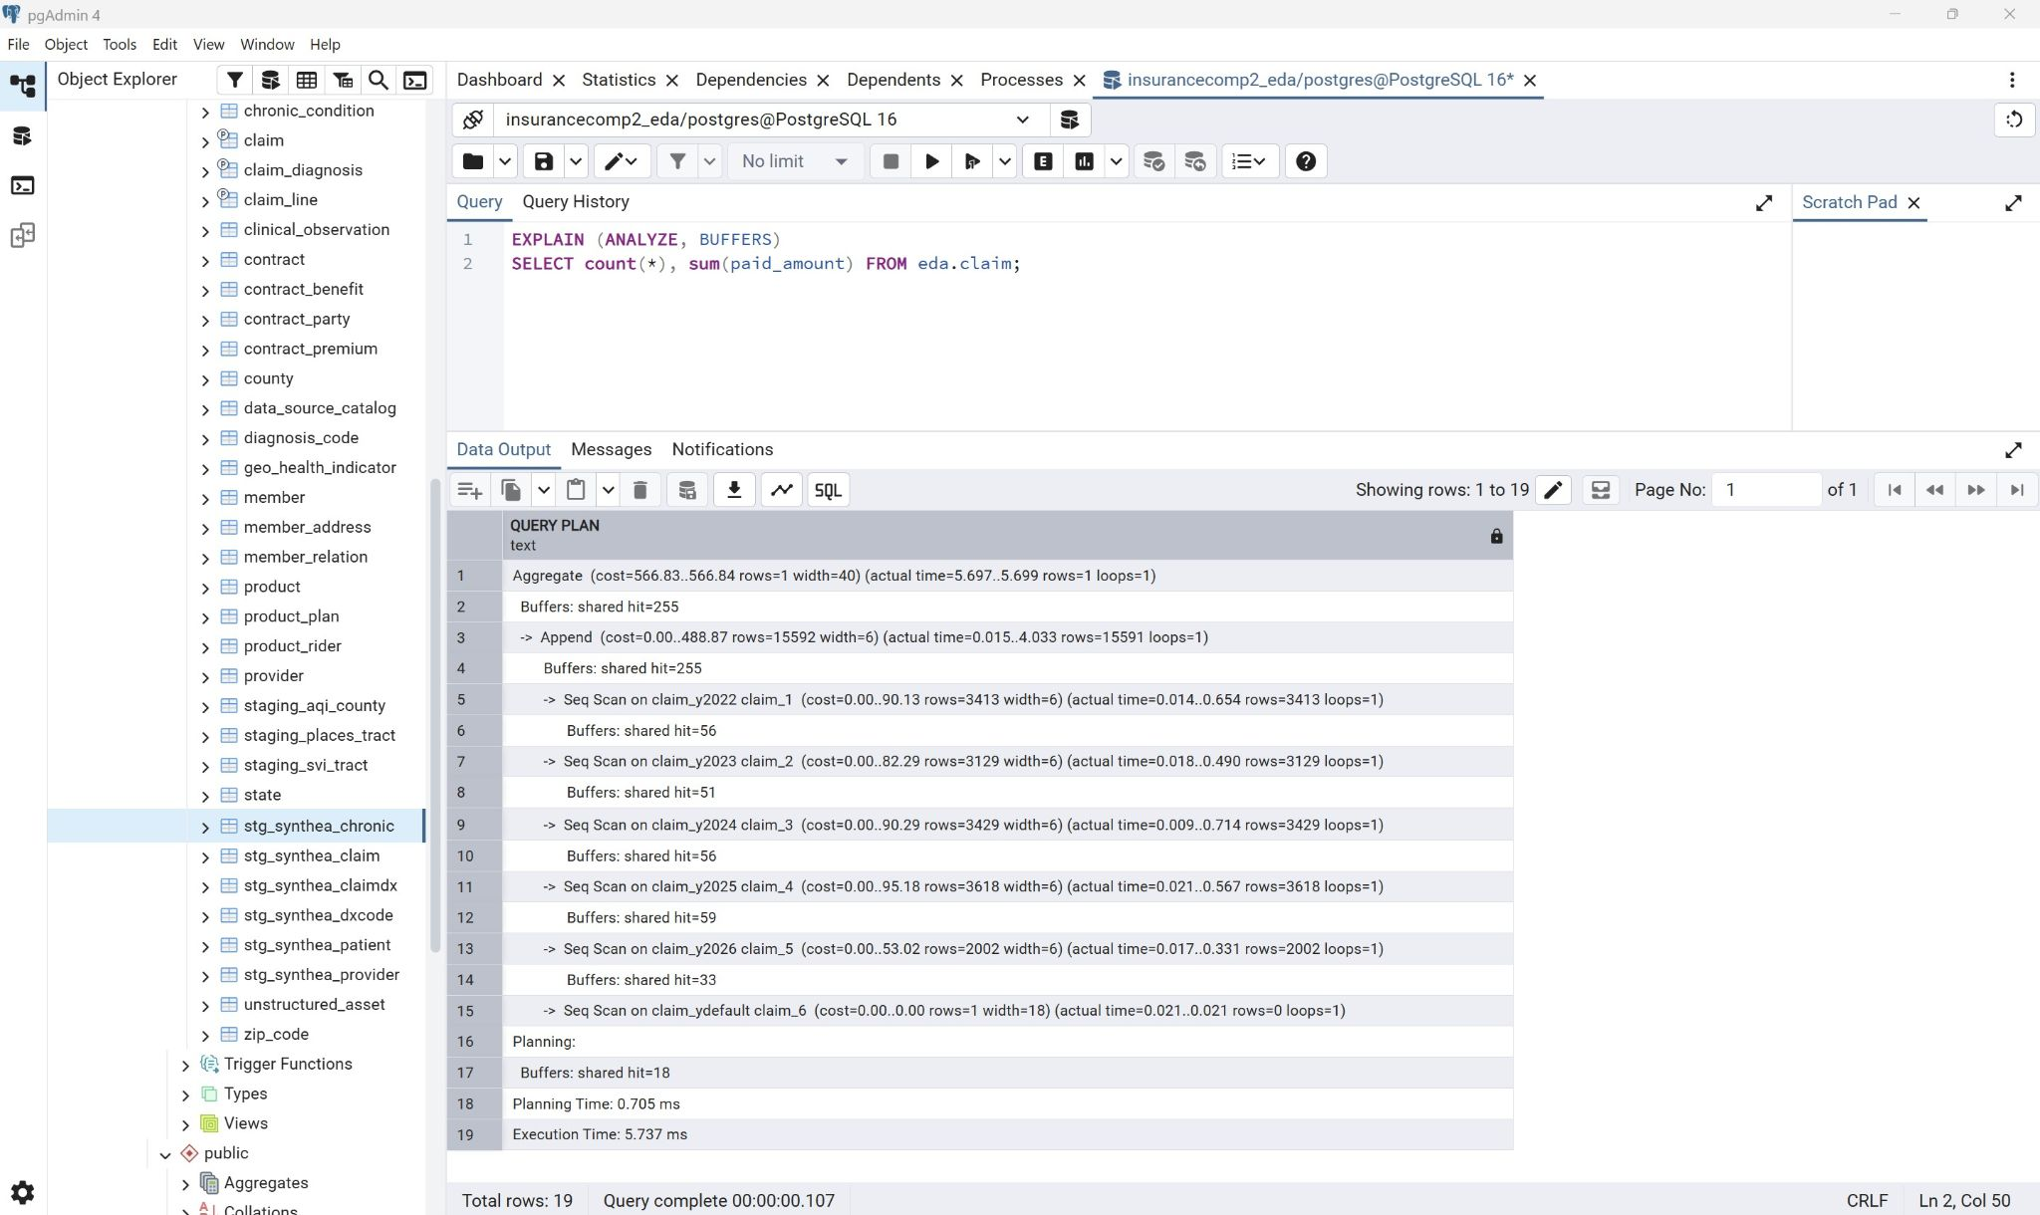
Figure: pgAdmin - EXPLAIN ANALYZE with no year filter showing all partitions traversed

- Clustering:
  - The geo_health_indicator was clustered on the composite lookup index since the access pattern is read heavy and appended in batches, it is read in county based bursts but only written in bulk during a data refresh. The clustering is a one time physical reorganization that does decay as rows are added and would need an annual refresh to keep it up to date.

- Selective materialization:
  - The materialized view county_risk_profile was created since geo_health_indicator stores indicators in tall form and every consumer would want them in wide form and the materialized view county_risk_profile performed that pivot once to save from computing that pivot on every quote request or model training run. A unique index was created on the view so that REFRESH MATERIALIZED VIEW CONCURRENTLY can run without blocking readers during a refresh
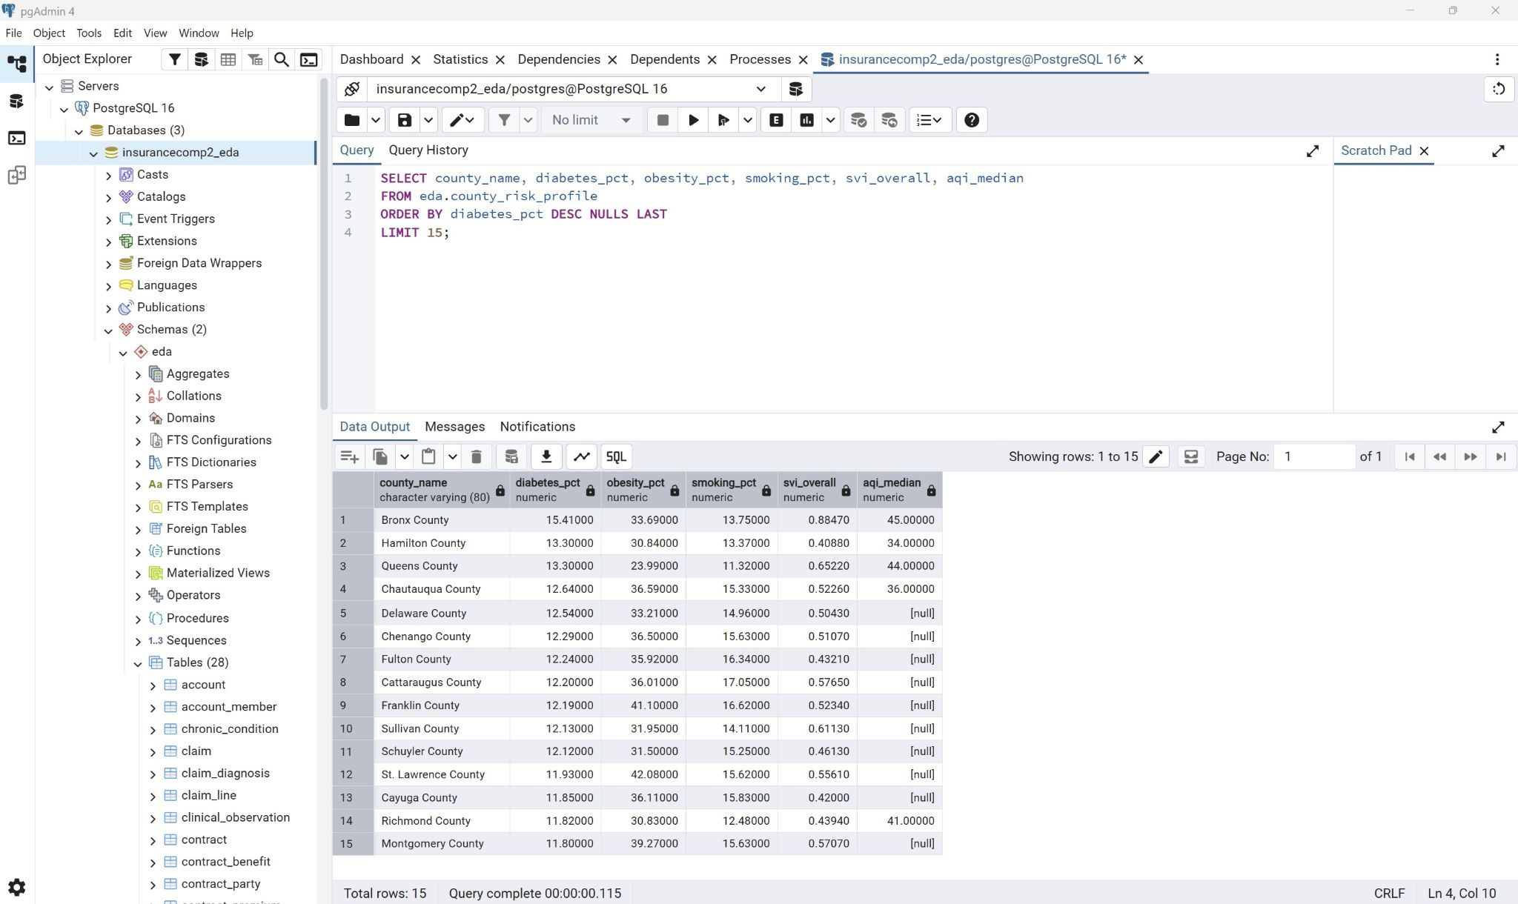
Figure: pgAdmin - county_risk_profile query output showing pivoted indicators per county

- Synthetic Patient Data:
  - Synthetic patient data generated using Synthea was used to simulate realistic volume in the physical design. These were generated using the open source synthetic patient generator focused on New York State. 607 synthetic patients were loaded and claims were filtered to the years 2022-2026.
The FIPS column was treated as the authoritative source when conflicts arose between County columns and FIPS since it joins reliably to census derived reference data. A few changes were made such as member.legacy_customer_id was widened to VARCHAR(40) from VARCHAR(32) since Synthea identifiers were 36 character UUIDs, a similar change was made for diagnosis_code.code widening it to VARCHAR(20) from VARCHAR(12) since SNOMED-CT extension codes ran to upto 17 digits. Additionally patients with no county FIPS code were loaded with null addresses instead of being dropped.
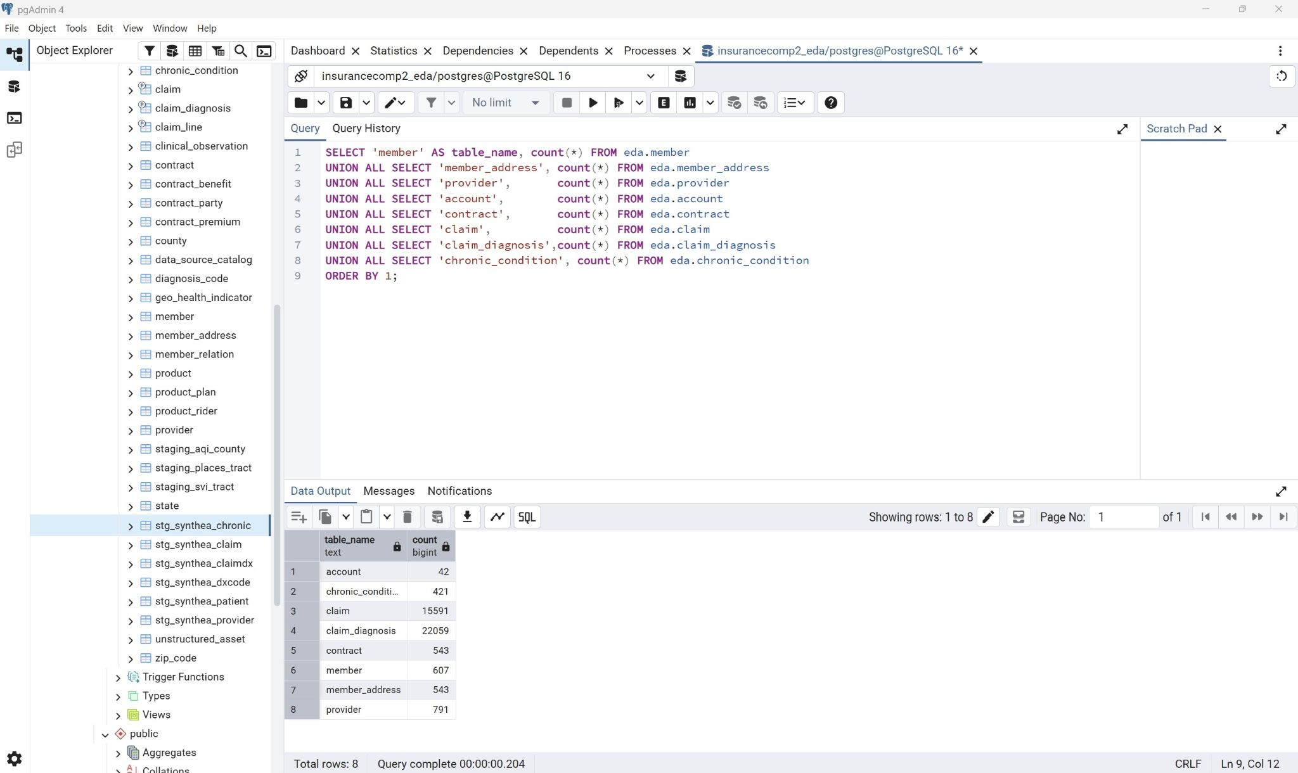
Figure: pgAdmin - row counts across member, provider, account, contract, claim and related tables

After the population was loaded the hybrid design was exercised with synthetic member join through their address and ZIP to county and from county to the CDC and EPA indicators.
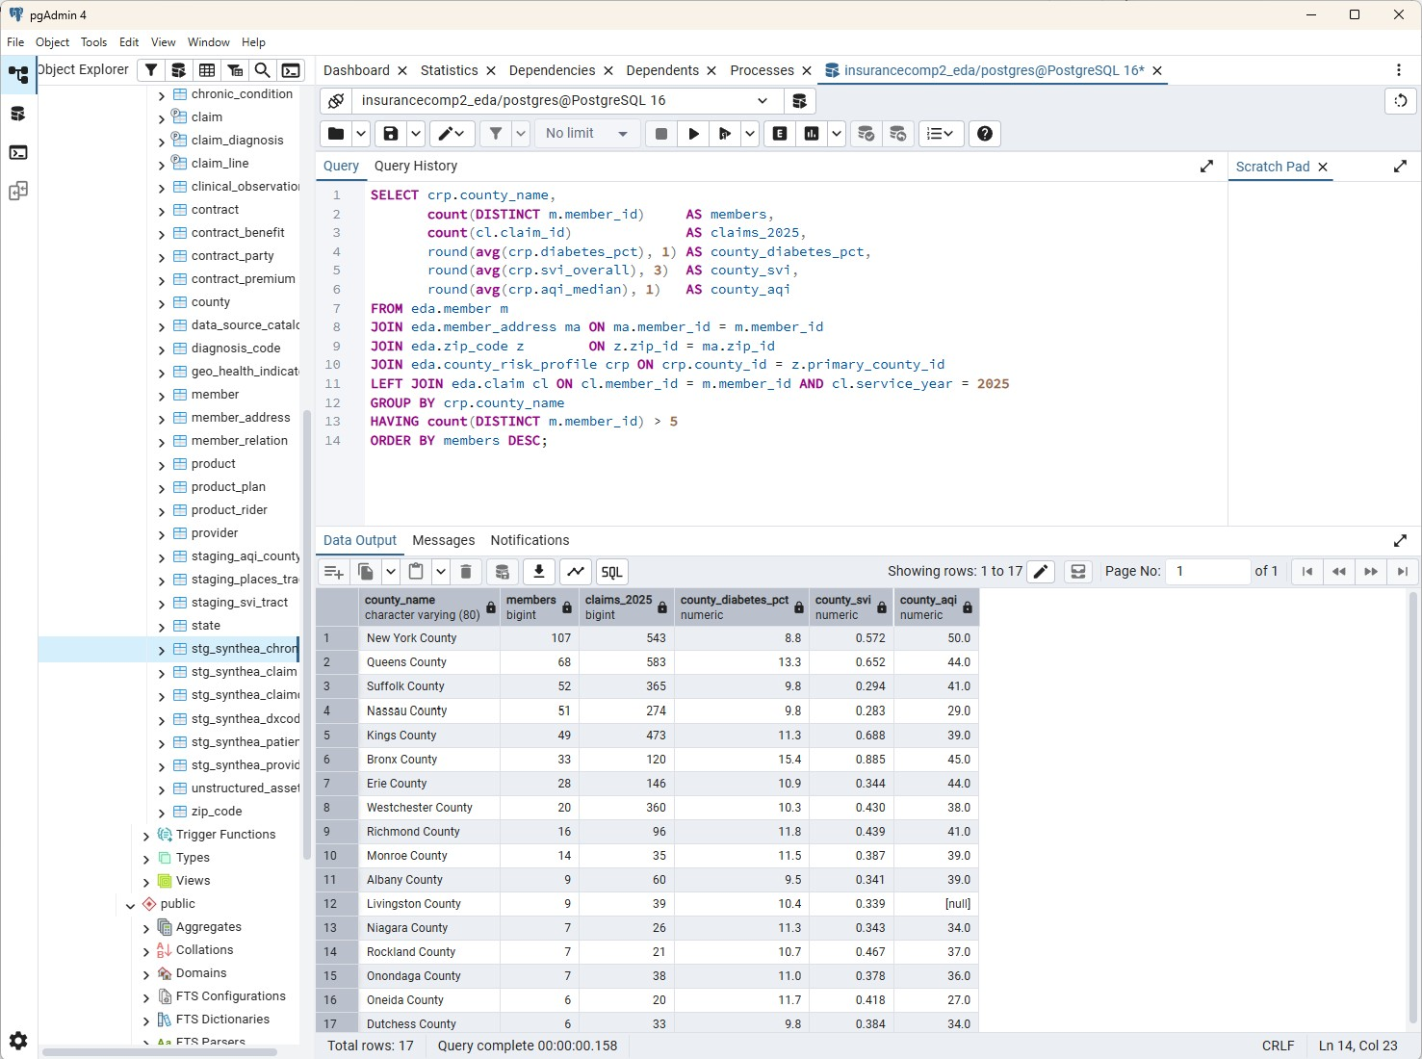
Figure: pgAdmin - hybrid join query showing members and claims per county with real health indicators
III - Business Use Cases
- The business use cases are explored using a use case diagram that documents the workflow of a customer obtaining an insurance quote and policy. In the use case diagram six actors are identified, namely Prospect/Customer, Sales Associate to initiate quotes, Underwriter to review applications, Actuarial to own the product and rate catalogs, Billing System to consume issued policies and to generate invoices, and Analytics Pipeline to refresh the risk model.
The use cases that these actors interact with contain 7 core use cases that represent the different steps in the core quote to policy path while Use Case 8 and Use Case 9 are background processes that inform the core path periodically/when required.

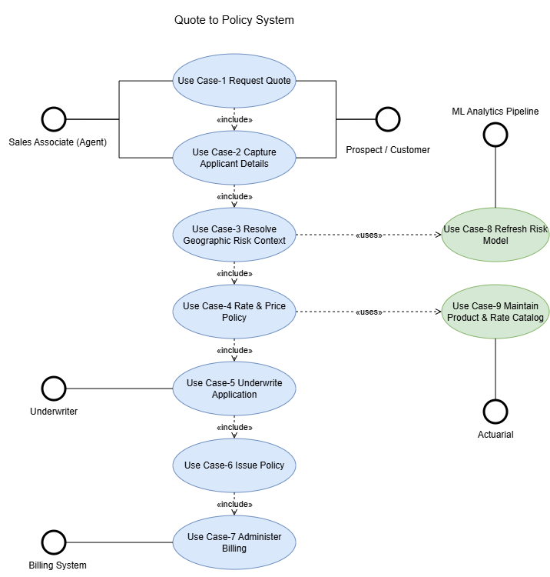
Figure: Use Case Diagram

The activity diagram showcases the sequence of activities and ownership of the business use cases. There are 5 rows representing Customer/Agent, Quote Service, Risk and Rating, Underwriting, and Policy Administration. The underwriting is only involved when auto approval fails and the policy administration does not take place till the customer accepts the policy.

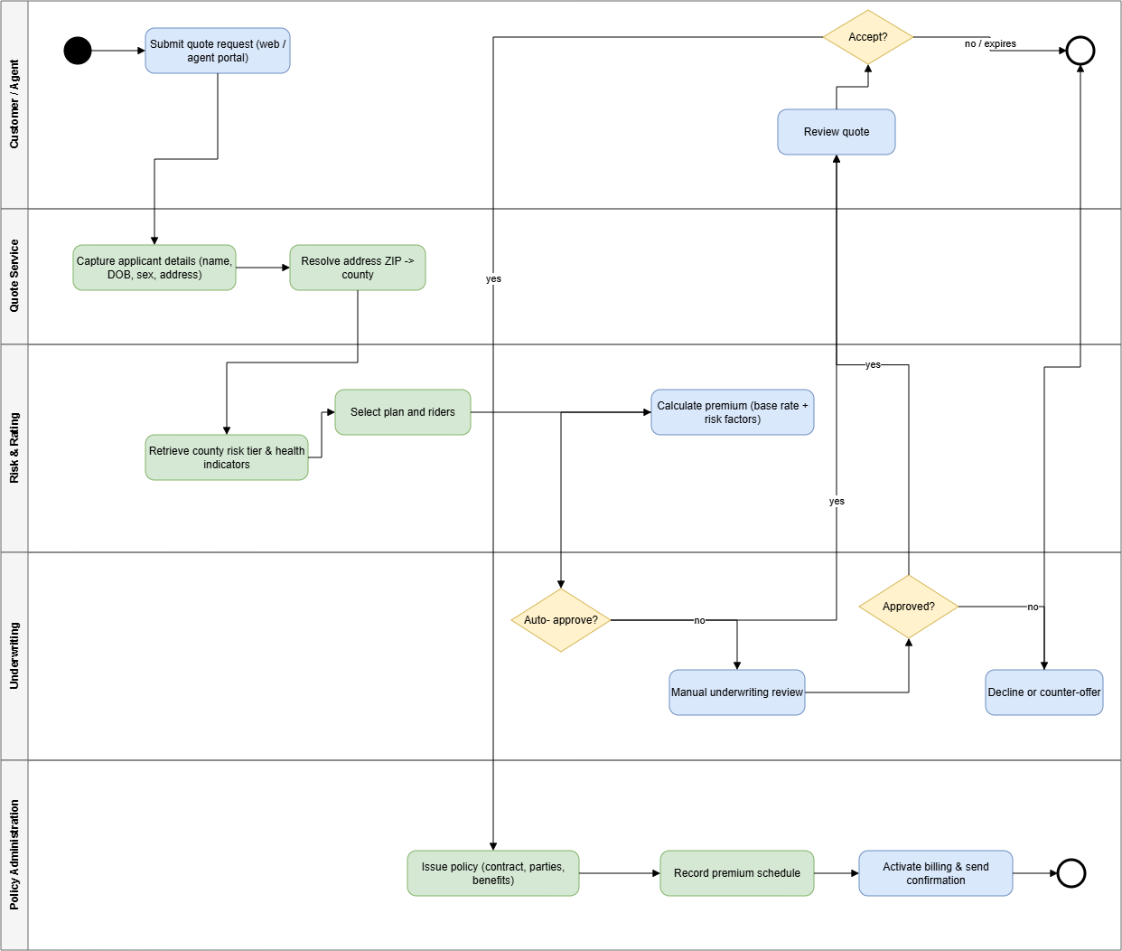
Figure: Activity Diagram

The use cases are as follows
- Use Case 1: Request a Quote
  - Involves Prospect/Customer
  - Prospect/Customer supplies applicant identity and address details, system validates that the fields are present and initiates a quote session
- Use Case 2: Capture Application Details
  - Involves Prospect/Customer, Sales Associate
  - System records name, DoB, sex at birth, contact details and address. System checks for an existing member by matching the natural key and if found the existing record is reused
- Use Case 3: Resolve Geographic Risk Context
  - Involves System
  - The system resolves the applicant’s ZIP code to a county through zip_code.primary_county_id. The system then retrieves the county’s risk tiers and chronic disease indicators and attaches them to the quote session.
- Use Case 4: Rate and Price the Policy
  - Involves System, Actuarial
  - The Actor selects a plan and any optional riders and the system retrieves base rates and benefit definitions from the product catalog. The system then calculates a modal premium from base rate, age band, coverage type and selected riders. The system then produces a quoted premium, deductible and out of pocket maximum.
- Use Case 5: Underwrite the Application
  - Involves Underwriter, System
  - The System applies automated underwriting rules and if all rules pass the application is auto approved. If not the application is routed to an underwriter for manual review
- Use Case 6: Accept Quote and Issue Policy
  - Involves Prospect/Customer, Sales Associate
  - Customer reviews and accepts the quote, the System then creates the contract with an effective date and in force flag. The system then records the customer as the insured party on the contract and selected benefits and the premium schedule. The system then links the contract to the appropriate group account when applicable
- Use Case 7: Administer Billing
  - Involves Billing System
  - Billing receives the contract and premium schedule and the first premium invoice is generated and confirmation documents are issued to the customer
- Use Case 8: Refresh the Risk Model (Independent background process)
  - Involves Analytics Pipeline
  - New source files are ingested into the data lake bronze zone and registered in data_source_catalog, tract level data is aggregated to county grain and loaded into geo_health_indicator. The materialized view county_risk_profile is refreshed and the regression and clustering models are retrained and county_risk_tier is reloaded
- Use Case 9: Maintain Product and Rate Catalog
  - Involves Actuarial/Product
  - Actuarial amends plans and riders and the base rates and benefit definitions are updated. The changes take effect for quotes generated after the effective date while existing contracts are unaffected.

IV - Machine Learning Model
- The Machine Learning model component was created using a Jupyter notebook titled ‘part3_ml_notebook.ipynb’. The business goal that informed the ML model builds upon the goal established in part II of forecasting chronic disease risk to inform insurance rates by using factors such as social vulnerability, health behaviour and environmental condition. This would allow the insurer to anticipate trends, claim burden, risk and plan accordingly.
All the predictors are drawn from different sources ranging from the CDC/ATSDR social vulnerability index to the EPA for air quality monitoring with the target for the approach coming from CDC PLACES.
The synthea patient data is not used for modelling since it is generated synthetic data, it was used for structure and volume for the physical design and workflow but since its conditions do not directly correlate with the real health statistics it was excluded.

The feature table joins the three data lake sources at a census tract level. SVI and PLACES join directly on the FIPS tract while EPA air quality is county level and is attached to every tract in its county. PLACES are pivoted to wide form and the CDC’s -999 suppression value is converted to null so suppressed tracts are excluded as opposed to being treated as real measurements.
This results in 5,289 census tracts across the 62 NY counties and we have 14 candidate socioeconomic predictors(of which 4 are excluded) and 9 chronic disease and behaviour targets.

Of the 14 candidate socioeconomic predictors 4 were excluded, namely Racial and ethnic composition, Limited English proficiency, Disability status and Single-parent household share. This was due to discrimination and regulatory concerns for the insurance company, a lot of these characteristics are either directly protected or are a close proxy for a protected characteristic.

Two algorithms were trained on the 10 remaining predictors and scored on a held out 25 percent test set with 5 fold cross validation so as to check that the result is not an artifact of one split.
For the primary target which was diagnosed diabetes prevalence the random forest achieved R squared of approximately 0.72 with a mean absolute error of approximately 1.3 percentage points with the strongest drivers being adults without high school diplomas. The same feature set generalises to the other six chronic conditions as well.

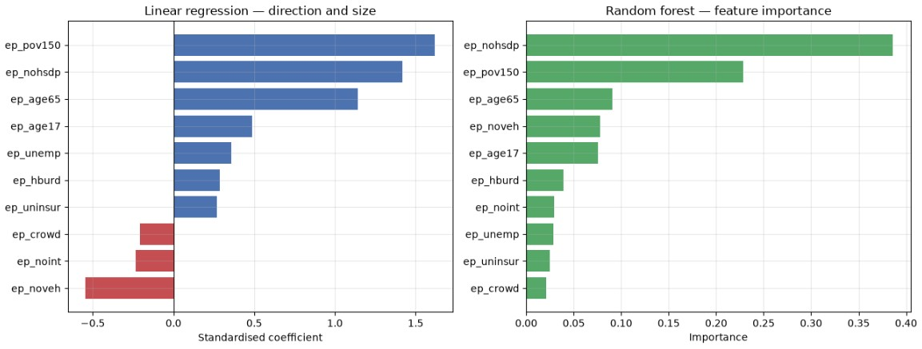
Figure: Jupyter Notebook - feature importance and standardised coefficients for the diabetes prevalence model

A point to note about the exclusion of the 4 ‘discriminatory’ predictors is that it would drop the model from a random forest R squared value of 0.838 to where we ended up which is ~0.72 which represents a drop of ~0.118 with the exclusion. The unconstrained model while being more accurate would not be suitable for this specific industry due to regulations hence the lower accuracy model was deemed more suitable for this application.

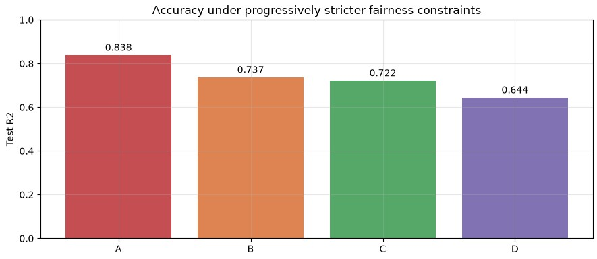
Figure: Jupyter Notebook - Model accuracy under progressively stricter fairness constraints

Regression predicts a number but territory planning and product design needed segments so K means clustering was used to group the 62 counties by their socioeconomic profile. An elbow scan across k values supported four clusters and the tiers were then relabelled in order of mean diabetes prevalence in order for the numbering to be interpretable. The tiers are to be read as multivariate socioeconomic profiles as opposed to a strict ranking.

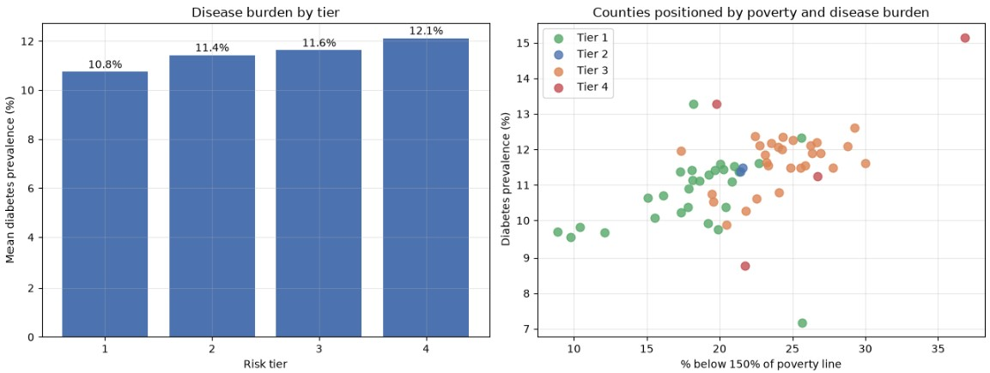
Figure: Jupyter Notebook - County risk tiers from k means clustering
The model output feeds insight back into the EDA by writing to county_risk_tiers and having it loaded back into PostgreSQL as eda.county_risk_tier that is keyed on county FIPS. The model output is queryable alongside member, contract and claim data since members reach a county through member_address and zip_code.

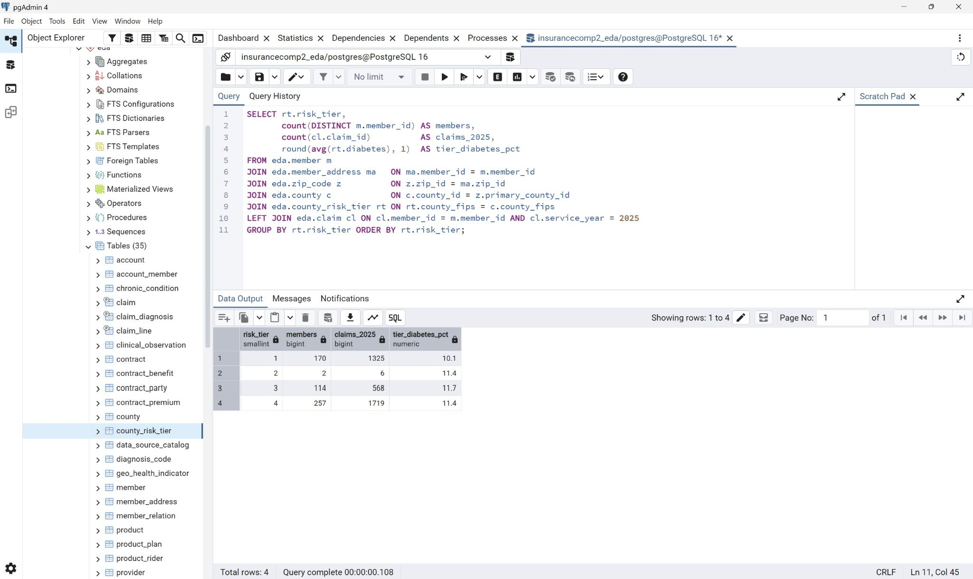
Figure: pgAdmin - members and claims distributed across ML derived risk tiers

In terms of value for the Insurance company
The short term value would be that the county risk tiers can inform territory and servicing planning and is available from the loaded county_risk_tier table.
The medium term value would be allowing the company to make tract level predictions to support product design in terms of which wellness riders/preventative benefits to offer in which markets and which territories would be most beneficial for outreach.
In the long term since the PLACES, SVI and AQI all refresh annually and accumulate in the same pipeline it can support trend detection over a longer period of time and can spot changing coverage and claim history and inform forecasting.

V - Big Data Platform and Cloud Analytics
- In order to leverage a big data platform and cloud analytics MongoDB was selected since it was used in Part II as well as the cloud platform and was extended to also aid in analysis and presentation.
Using MongoDB alongside PostgreSQL, the raw layer holds the semi structured source files that have varying schema.
Two aggregation pipelines were run against the bronze database in MongoDB atlas. The first performed a cross collection join that links each PLACES tract to its corresponding SVI record on tract FIPS and bin tracts into social vulnerability quartiles and reports mean diabetes prevalence per quartile. This results in a clean monotonic gradient with mean diabetes prevalence rising from ~8.96 % in the least vulnerable quartile to ~14.88 % in the most vulnerable.

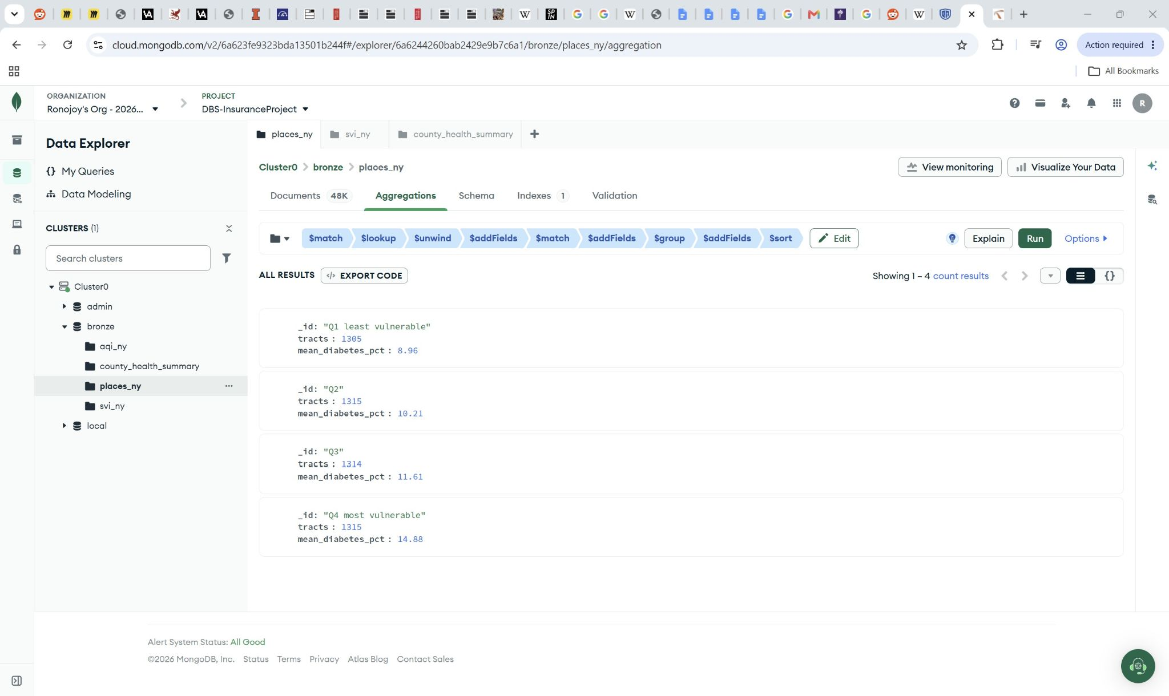
Figure: MongoDB Atlas - aggregation pipeline output showing diabetes prevalence by SVI quartile

The second pipeline computes the population weighted mean prevalence per county per measure across all nine conditions and writes the result into a new county_health_summary collection containing 558 documents.

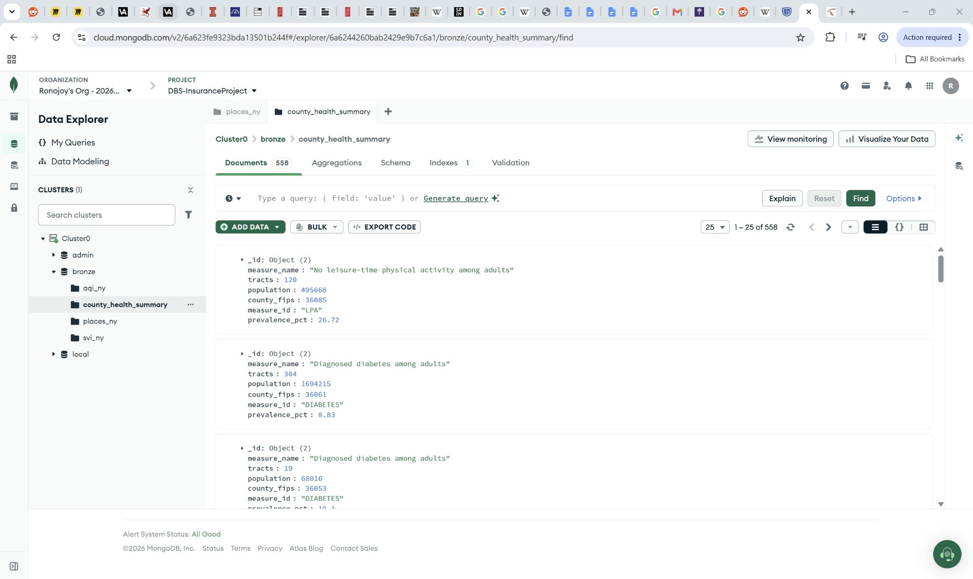
Figure: MongoDB Atlas - county_health_summary collection created with 558 documents

Atlas charts were used to present the analytics results reading from the county_health_summary collection that was produced by the second pipeline showing prevalence across NY counties for each of the nine chronic disease and behavioural measures.

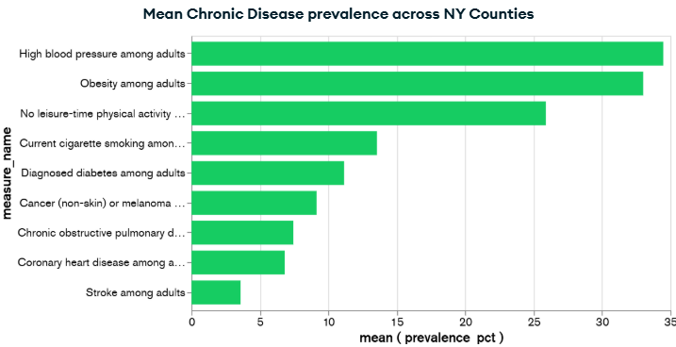
Figure: MongoDB Atlas Charts - dashboard showing mean chronic disease prevalence across NY counties

VI - Refined Reference Architecture
- The reference architecture that was mentioned in part II was extended to account for 2 additional layers for machine learning and a feedback loop for returning the model output back to the operational schema.

Thus the layers of the reference architecture would be
- Layer: Sources
Content: 3 datasets (SVI, PLACES, AQI) at native grain and Synthea synthetic patient data
Where: Stored in CSVs

- Layer: Data lake - Bronze
Content: Raw files that are unmodified and catalogued by the grain/license/source
Where: MongoDB Atlas

- Layer: Data lake - Curated
Content: County level aggregation
Where: Staging tables to geo_health_indicator and the county_health_summary collection in Atlas

- Layer: Physical Schema
Content: Normalized eda schema with indexes, partitions, clustering and materialized views
Where: PostgreSQL 16

- Layer: Machine Learning
Content: Feature extraction, regression and clustering models
Where: Jupyter

- Layer: Analytics and Presentation
Content: Insights, Reporting, Actuarial and Marketing consumption, Atlas Charts
Where: ODS/BI Warehouse, Atlas Charts

- Layer: Governance
Content: wraps all layers and has contains_phi flag, quality_status, source licensing
Where: data_source_catalog/ unstructured_asset metadata

The biggest change from part II is that the architecture is not a one way pipeline since the machine learning layer produces county_risk_tier which is loaded back into the operational schema to be read by the quote workflow.
VII - Governance and Fairness
- DIKW governance safeguards against bias in socio technical systems in order to ensure fairness and accountability. This is achieved by having governance and fairness mechanisms in place. The contains_phi flags on data_source_catalog and unstructured_asset account for if the record contains any personal or protected information which is especially important since they are all aggregate geographic statistics. There is also a retention_class column on unstructured_asset that alongside the year based partitioning allows a retention policy to be enforced.
For fairness the 4 predictors that were mentioned earlier were excluded. The excluded predictors were racial and ethnic composition, Limited English proficiency, Disability status and Single-parent household share. This helps enforce fairness and to follow discrimination and regulatory concerns for the insurance company with the cost of the exclusion being a drop ~0.118 in accuracy. Operationally any application that fails auto approval gets routed to human review to ensure oversight and accountability.

VIII - Conclusion
- Part III of the project deployed a physical design applying indexing, partitioning, clustering and selective materialization and was deployed against synthetic population data. A quote to policy workflow was specified and machine learning models were trained on cross source data to produce usable predictive accuracy and county risk tiers that are loaded back into the schema. The big data platform was extended from storage to also include analysis and presentation.

